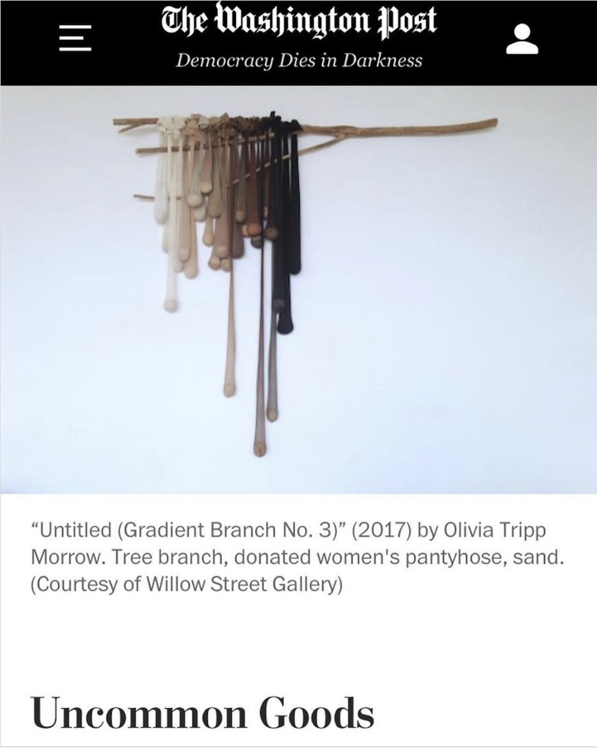
In the Galleries: Uncommon Goods feature in The Washington Post
February 21, 2020 in Exhibitions, Media
Uncommon Goods | Willow Street Gallery January 31 - March 1, 2020 Closing reception and artist talk: 1:30pm on Sunday, March 1
As published via The Washington Post on Friday, February 21, 2020
“Sometimes the results of alchemy aren’t all that precious. The four area artists in Willow Street Gallery’s ‘Uncommon Goods’ work with everyday stuff, making things that intentionally retain much of the materials’ ordinariness.
Olivia Tripp Morrow turns frayed women’s undergarments into wall sculptures; the one that most alters the garments treats pantyhose as vines suspended from a real tree branch. Nicole Salimbene also arrays dangling objects, but hers are pages of Artforum magazine, rolled so they register simply as black and white columns. The forms in Sarah Irvin’s handsome cyanotypes are derived from her daughter’s toys, which yield house-like shapes in shades of blue and tan. All three women are remarking on customary notions of female roles, whether as sex objects, marginalized artists or wives and mothers.
Damon Arhos joins the conversation by using irons — associated with domestic chores more often performed by women — in place of brushes. Executed in white and black on brown wood, his abstract pictures consist of drips and repeated outlines of the appliance’s flat surface. The shape might be hard to identify if the artist hadn’t lined up three paint-spattered irons below one of his paintings. Like his cohorts, Arhos doesn’t disguise his work’s commonplace origins.”
In the galleries: Uncommon Goods
Mark Jenkins | The Washington Post

