Odd Works: 2
September 1 to October 7, 2012
Curated by: Russell Lord, director of photography for the New Orleans Museum of art.
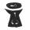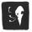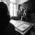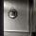

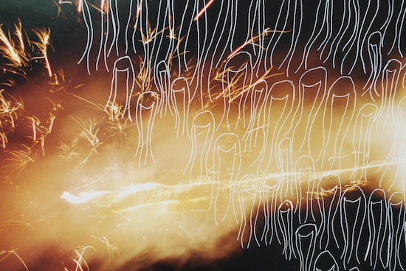

Berlin (New Year?s Eve) by Saul Robbins

